International Cybersecurity and Digital Forensics Academy (ICDFA)
CIP-B102 Foundations of Computer and Digital Forensics
LAB 4 REPORT
USB Image Acquisition and Hash Verification
Student Practical Report

Course Code | CIP-B102
Course Title | Foundations of Computer and Digital Forensics
Lab Number | Lab 4 – USB Image Acquisition and Hash Verification
Student Name | Fuseini Imoru Kantuogaa
Registration Number | C11/26/DFIT/17291
Instructor Name | Dr. Sarah James
Lab Dates | 07 July 2026 – 08 July 2026
Report Submission Date | 09 July 2026

1. Pre-Lab Reading Confirmation
I confirm that I reviewed the CIP-B102 course material on USB Image Acquisition before beginning this practical lab, including the concept of a forensic disk image, the reason hashing is required for evidence integrity, and the distinction between a bit-for-bit forensic image and an ordinary file copy. A file copy only reproduces the visible, allocated files on a volume, whereas a forensic image captures every sector of the source media including unallocated space, slack space, and metadata in a repeatable and independently verifiable form. This understanding guided the acquisition and verification steps carried out below.

2. Lab Overview
Scenario: acting as a junior digital forensics trainee, a test USB flash drive was prepared with a controlled evidence file, forensically imaged, hashed, and the resulting image was independently verified for integrity across two separate machines (Windows and Kali Linux) before its contents were validated.

3. Evidence Acquisition Form
Case/Lab ID | 001
Student Name | Fuseini Imoru Kantuogaa
Registration Number | C11/26/DFIT/17291
USB Brand/Description | DIGIRICH USB flash drive, recognised in Windows as “Win10x64IE (F:)”
USB Capacity | 16 GB nominal (14.4 GB usable/free as shown in File Explorer, Figure 1)
Date and Time Received/Prepared | 07/07/2026
Acquisition Method Used | Windows – FTK Imager physical-drive acquisition (\\.\PHYSICALDRIVE2) to a raw/dd image, followed by a network transfer of the image to a Kali Linux host for independent verification and Linux-based validation
Tool Used and Version | FTK Imager 8.2.0.59 (acquisition and internal hash verification); certutil and Kali md5sum/sha256sum (independent hash verification); Kali fdisk and mount (image validation)
Image File Name | CIPB102_Lab4_Fuseini_Imoru_USB.dd.001 (with companion .csv and .txt log files generated by FTK Imager)
Image Storage Location | Windows: C:\Users\user\Desktop\New folder\ ; copied to Kali Linux: ~/Lab4/
Hash Algorithm Used | MD5 and SHA1 (computed automatically by FTK Imager and compared against its own report hash), plus MD5 and SHA256 (independently recomputed with certutil on Windows and md5sum/sha256sum on Kali)
Examiner Signature | Fuseini Imoru Kantuogaa

4. Tool and Environment Description
- Acquisition host: Windows 10 (build 10.0.26200.8737), administrator command prompt and FTK Imager 8.2.0.59 running as Administrator.
- Verification/validation host: Kali Linux, reachable on the lab network at 192.168.44.128, connected to the Windows host at 192.168.44.1 via a VMware host-only/NAT adapter.
- Evidence media: DIGIRICH USB flash drive, detected by Windows as Physical Drive 2 and as “Win10x64IE (F:)” in File Explorer.
- No hardware write blocker was available for this exercise. This limitation is acknowledged; care was instead taken to select the correct physical drive in FTK Imager and to avoid any write operation to the source USB after the evidence file was created.

5. Step-by-Step Procedure

5.1 Task 1 – Preparing the USB Evidence Media
The DIGIRICH USB drive was inserted and appeared in File Explorer as “Win10x64IE (F:)” with 14.4 GB free of 14.4 GB, confirming the drive was empty and ready for evidence preparation.
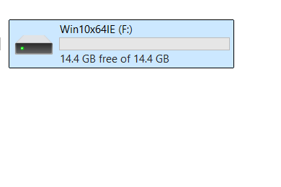
Figure 1. USB drive visible in File Explorer as Win10x64IE (F:), 14.4 GB free.
A folder named CIP-B102-Lab4-Evidence was created on the drive, and inside it a text file, PDF file, and PNG image were placed so that the resulting image would contain more than one file type, as permitted by the optional step in Task 1.
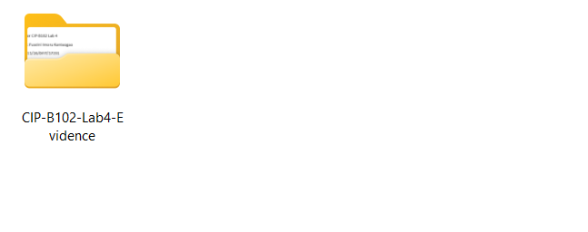
Figure 2. Evidence folder CIP-B102-Lab4-Evidence created on the USB drive.
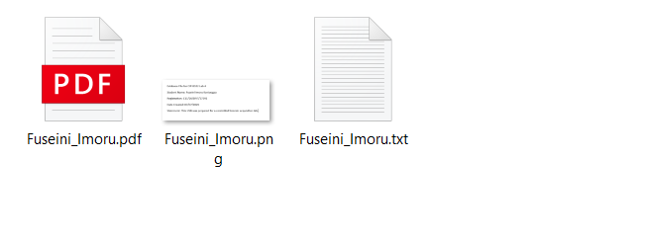
Figure 3. Folder contents: Fuseini_Imoru.txt, Fuseini_Imoru.pdf and Fuseini_Imoru.png.
The text file was populated with the required evidence statement, including student name, registration number, date created, and a statement confirming the USB was prepared for a controlled forensic acquisition lab.
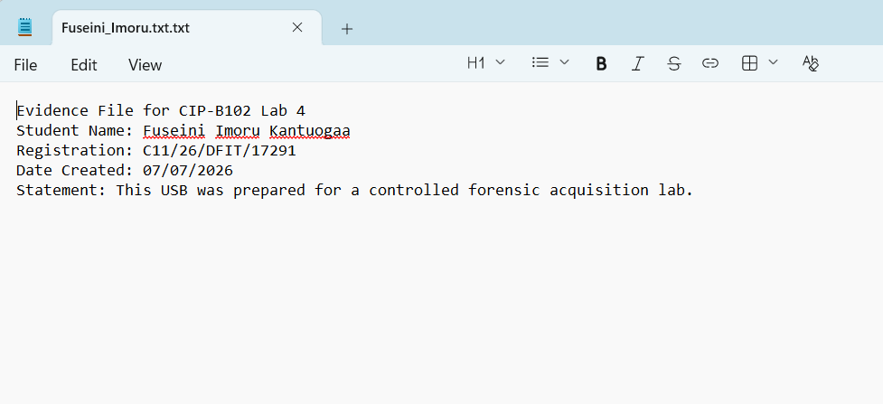
Figure 4. Content of Fuseini_Imoru.txt confirming student details and the controlled-acquisition statement.

5.2 Task 3, Option A – Windows Acquisition Using FTK Imager
FTK Imager 8.2.0.59 was launched with administrator privileges. File > Create Disk Image was used to begin acquisition, and the Physical Drive corresponding to the DIGIRICH USB (\\.\PHYSICALDRIVE2) was selected so that the entire physical device – not just the visible volume – would be captured. The Raw (dd) image type was chosen, with the destination folder set to C:\Users\user\Desktop\New folder\ and the output file named CIPB102_Lab4_Fuseini_Imoru_USB.dd, which FTK Imager automatically saved as CIPB102_Lab4_Fuseini_Imoru_USB.dd.001. The image was deliberately saved to the internal hard drive rather than back onto the source USB.

FTK Imager first built a directory listing of the source drive, then created the image itself:
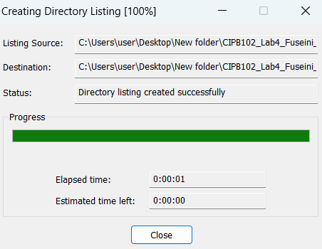
Figure 5. FTK Imager creating the directory listing of the source drive (100% complete).
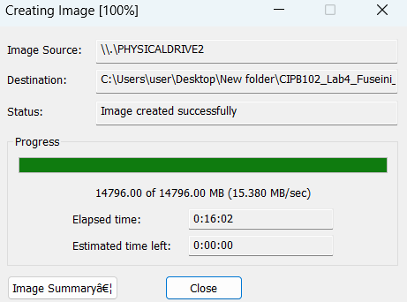
Figure 6. FTK Imager creating the disk image from \\.\PHYSICALDRIVE2 – 14,796.00 of 14,796.00 MB completed at 15.380 MB/sec, status: image created successfully.

FTK Imager's built-in verification then compared the hash it computed while reading the source against the hash recorded in its own report, for both MD5 and SHA1:
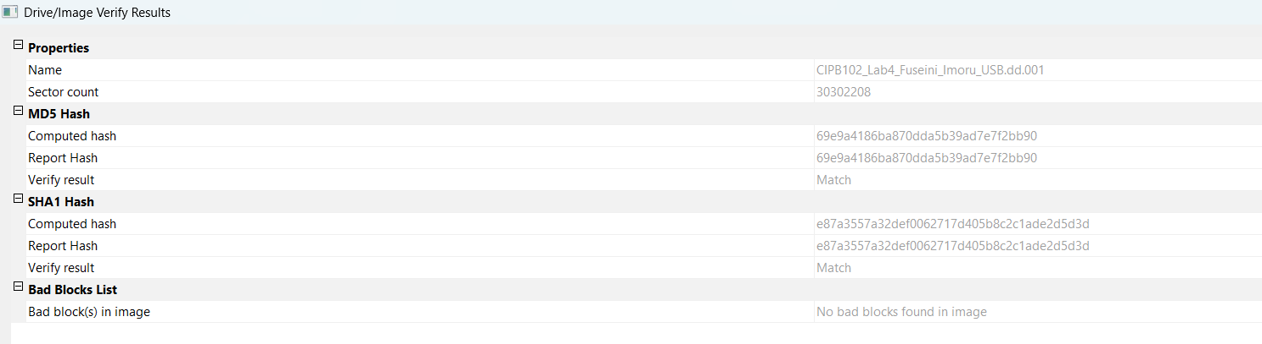
Figure 7. FTK Imager Drive/Image Verify Results: MD5 (69e9a4186ba870dda5b39ad7e7f2bb90) and SHA1 computed/report hashes match, and no bad blocks were found in the image.

5.3 Optional Task, Option C – Network Transfer of the Image to Kali Linux
To provide an independent, second-machine verification of the acquired image (the optional network-acquisition/transfer concept in Task 3, Option C), the completed image was transferred from the Windows acquisition host to a Kali Linux VM over the isolated lab network, rather than relying solely on the single Windows machine to judge its own image.
The Command Prompt was used to confirm the image and its companion log files were present on the Windows Desktop:
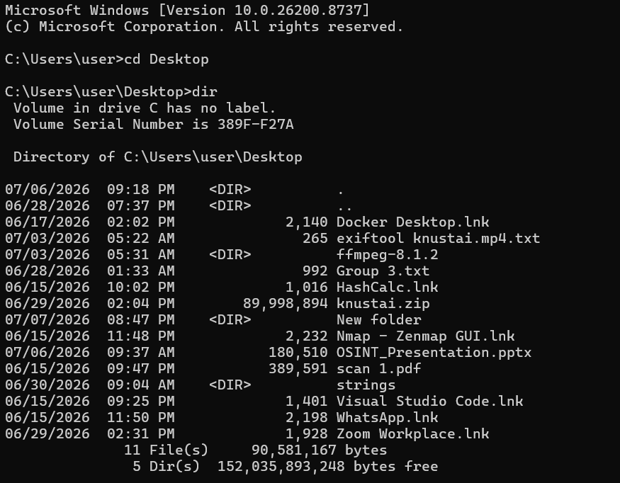
Figure 8. Windows command prompt: directory listing of the Desktop showing tools used to prepare the environment.
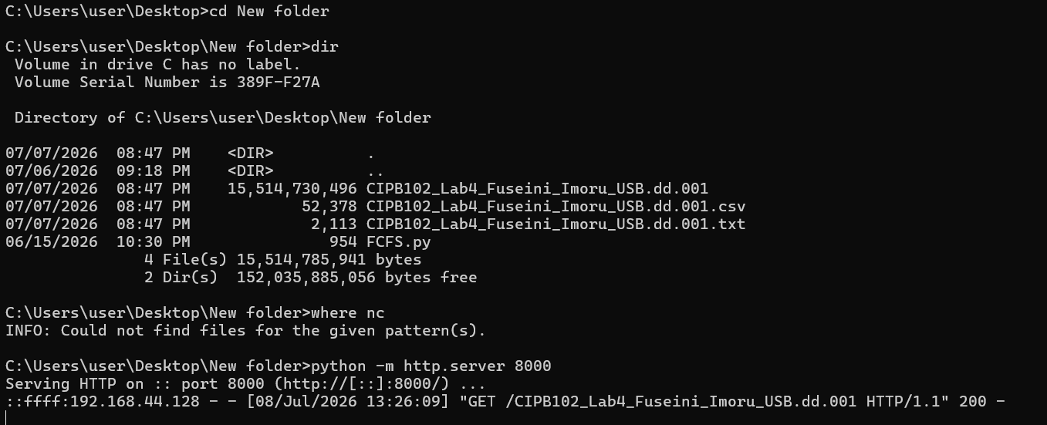
Figure 9. The completed image file CIPB102_Lab4_Fuseini_Imoru_USB.dd.001 (15,514,730,496 bytes) with its .csv and .txt FTK log files. “Where nc” returned no result because netcat was not installed on Windows, so a Python HTTP server (python -m http.server 8000) was started instead to serve the image for transfer, and the Kali host's request for the file is logged.
Network adapter details were captured on the Windows host to record the transfer path (172.26.64.1 / 192.168.44.1 host-only network used to reach the Kali VM):
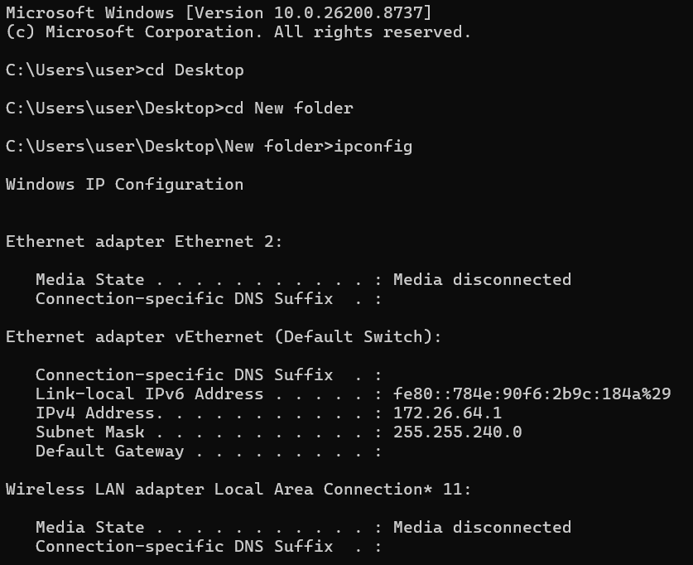
Figure 10. Windows ipconfig output showing the Ethernet and vEthernet adapters.
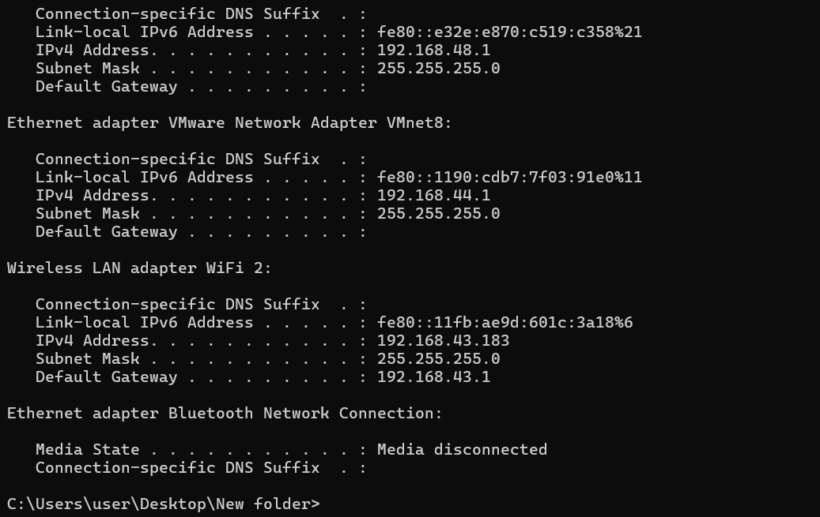
Figure 11. Windows ipconfig output (continued) confirming the 192.168.44.1 VMware host-only adapter used for the transfer.
On the Kali side, a netcat listener was first attempted as the initial network-transfer method, then suspended in favour of the HTTP download once the Python server was confirmed running on the Windows side:
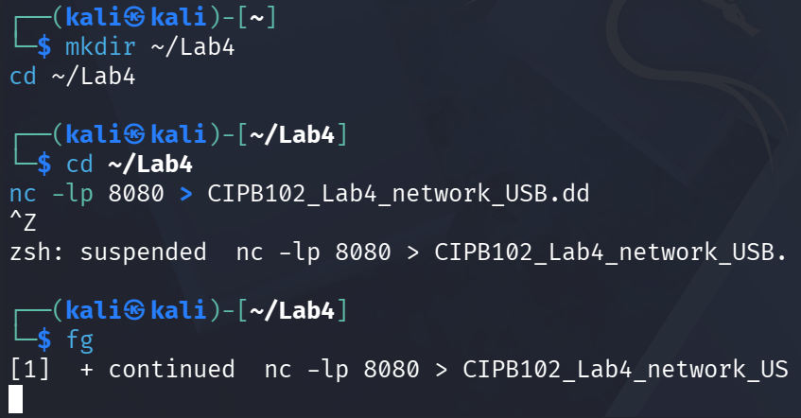
Figure 12. Kali Linux: netcat listener (nc -lp 8080) started and then suspended/backgrounded (fg) while the HTTP transfer method was used instead.

The image was then retrieved from the Windows HTTP server using wget from the Kali VM (hostname -I confirmed the Kali IP as 192.168.44.128):
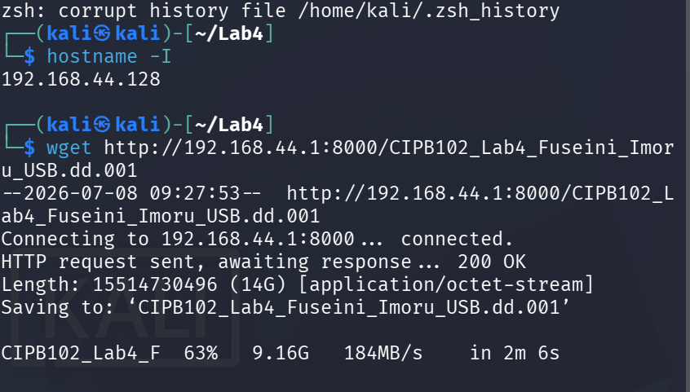
Figure 13. wget transfer of CIPB102_Lab4_Fuseini_Imoru_USB.dd.001 in progress (63%, 184 MB/s).
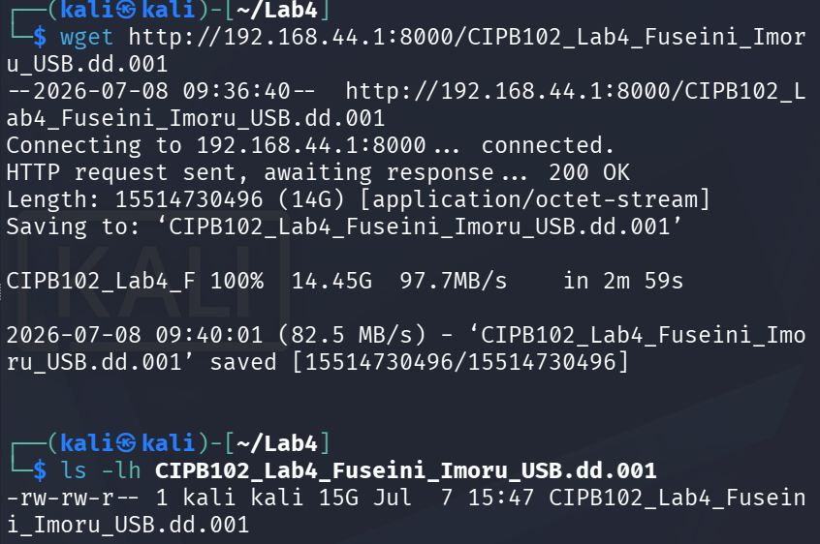
Figure 14. wget transfer completed – 14.45 GiB received in 2 minutes 59 seconds; ls -lh confirms the 15 GB image file on the Kali host.

5.4 Hash Verification (Windows and Kali)
The MD5 and SHA256 hashes of the image were independently recomputed on the Windows host with certutil, and again on the Kali host with md5sum and sha256sum, after the network transfer:
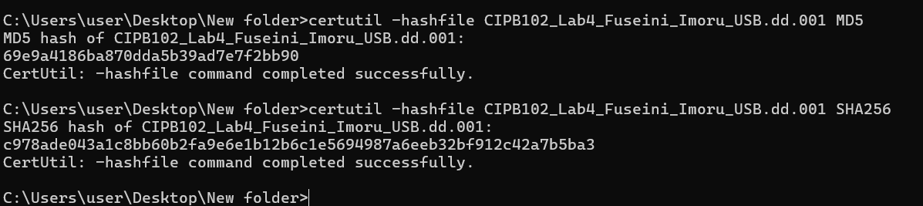
Figure 15. Windows certutil -hashfile results for MD5 and SHA256 on the original acquired image.
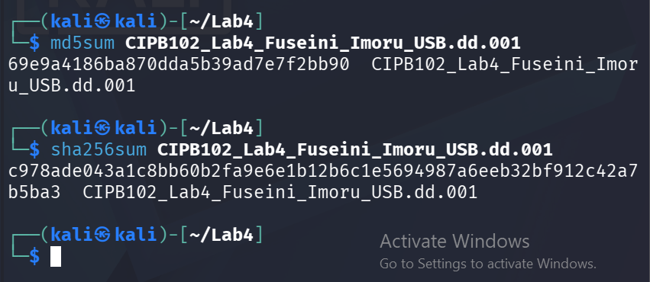
Figure 16. Kali Linux md5sum and sha256sum results on the transferred copy of the image, identical to the Windows values.
Both MD5 (69e9a4186ba870dda5b39ad7e7f2bb90) and SHA256 (c978ade043a1c8bb60b2fa9e6e1b12b6c1e5694987a6eeb32bf912c42a7b5ba3) values matched exactly between the Windows source copy and the copy transferred over the network to Kali, confirming that the image arrived byte-for-byte intact.

5.5 Task 6, Method 2 – Linux Read-Only Mount Validation
Rather than previewing the image inside FTK Imager, the image was validated on the Kali host by inspecting its partition table and mounting it read-only, per Method 2 of the lab guide. fdisk confirmed a GPT-partitioned 14.45 GiB disk with a 14.4 GB Windows data partition and a small Microsoft-reserved partition, and the data partition offset (1,048,576 bytes = sector 2048 × 512) was used for the mount:
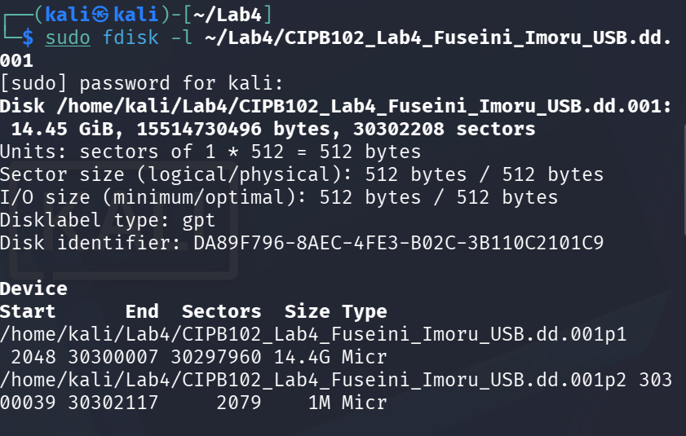
Figure 17. sudo fdisk -l on the acquired image showing the GPT partition table and the 14.4 G data partition used for the mount offset.
The image was mounted read-only using the calculated partition offset so that the evidence copy would not be altered during validation:
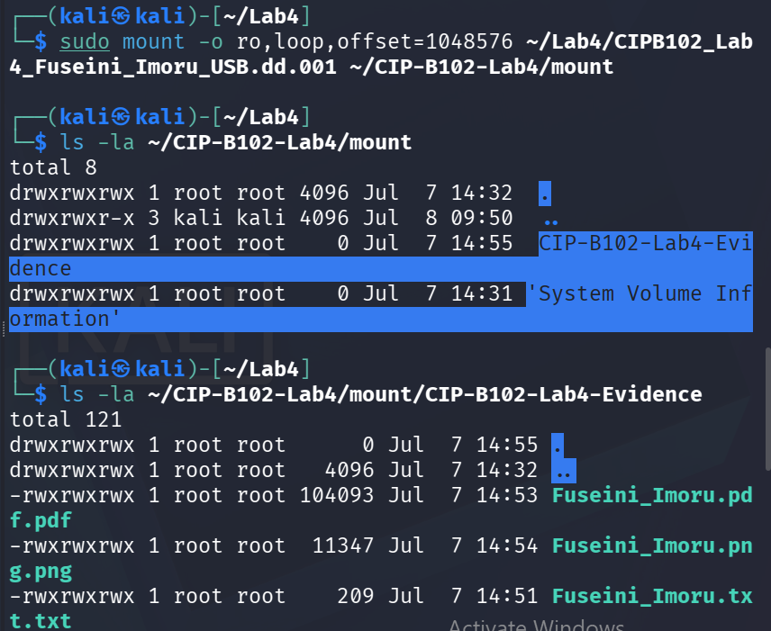
Figure 18. Read-only loop mount of the image (offset=1048576); the CIP-B102-Lab4-Evidence folder and its three files (txt, pdf, png) are visible inside the mounted image.
Finally, the content of the evidence text file was read directly from the mounted image and found to be identical to the original file created in Task 1, proving that the acquired image faithfully preserves the evidence:
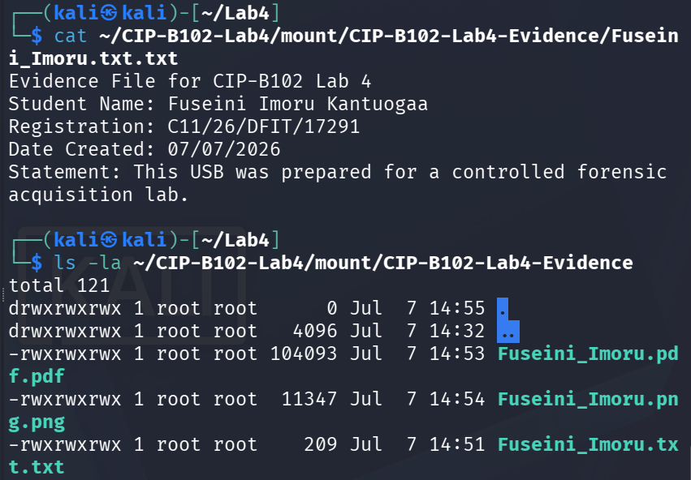
Figure 19. cat of Fuseini_Imoru.txt from the mounted image, showing content identical to Figure 4, and a repeat directory listing confirming all three evidence files are present.

6. Hash Verification Table
The table below summarises all hash comparisons performed during this exercise.
Evidence Item | MD5 Hash | SHA256 Hash | Match/Comment
Acquired image (Windows – FTK Imager + certutil) | 69e9a4186ba870dda5b39ad7e7f2bb90 | c978ade043a1c8bb60b2fa9e6e1  b12b6c1e5694987a6eeb32bf912c42a7b5ba3 | Baseline
Acquired image (after network transfer to Kali) | 69e9a4186ba870dda5b39ad7e7f2bb90 | c978ade043a1c8bb60b2fa9e6e1b12  b6c1e5694987a6eeb32bf912c42a7b5ba3 | MATCH
FTK Imager internal verify (Computed vs. Report hash) | 69e9a4186ba870dda5b39ad7e7f2bb90 (MD5) | SHA1:e87a...def0062717d405  b8c2c1ade2d5d3d | MATCH
Recovered/mounted image (Linux loop mount) | n/a – verified by content | n/a – verified by content | Content byte-identical (see Figure 19)
Note: no separate raw-device hash of /dev/sdX or PHYSICALDRIVE2 was captured outside of FTK Imager, since FTK Imager itself computes the hash from the data as it is read from the source during acquisition and then compares it to the report hash it generates (Figure 7). This built-in computed-vs-report comparison serves the same integrity-checking purpose as hashing the source device directly, and it passed for both MD5 and SHA1.

7. Image Content Validation
The acquired image was proven to contain the expected evidence exactly as created in Task 1:
- The mounted image (Figure 18) contains the CIP-B102-Lab4-Evidence folder with all three files: Fuseini_Imoru.txt (209 bytes), Fuseini_Imoru.pdf (104,093 bytes), and Fuseini_Imoru.png (11,347 bytes).
- The text content read from the mounted image (Figure 19) is word-for-word identical to the original file shown in Figure 4, including the student name, registration number, date, and controlled-acquisition statement.
- File sizes and content matched with no corruption, confirming the acquisition and network transfer preserved the evidence bit-for-bit.

8. Reflection
This lab reinforced why forensic imaging is fundamentally different from copying files: imaging the whole physical drive with FTK Imager captured the device exactly as presented to the operating system, and every step of that process could be independently checked with a hash rather than taken on trust. The most important safeguard was selecting the correct physical drive (\\.\PHYSICALDRIVE2) before starting the acquisition, since imaging the wrong disk for example, an internal drive could destroy data irreversibly; this was double-checked against the drive size and label before the imaging step began.
A practical obstacle arose when attempting the optional network-acquisition step: netcat (nc) was not available on the Windows acquisition host, so a Python HTTP server was used instead to serve the image, with wget on the Kali side used to retrieve it. This substitution achieved the same goal – moving the image to a second machine for independent verification and it also served as a reminder that forensic procedures sometimes need to be adapted to the tools actually available while still preserving the underlying evidentiary requirements.
Hash verification was the most valuable step in the whole exercise. FTK Imager's own computed-versus-report comparison confirmed the image was written correctly on the Windows side, and then completely independent tools (certutil and Kali's md5sum/sha256sum) were used to recompute the hashes after the image had travelled over the network. Because all values matched exactly, this provided strong, tool-independent evidence that no bit of the image was altered in transit. Lastly, mounting the image read-only in Kali rather than mounting it read-write, or editing files inside it was essential to avoid contaminating the evidence during validation. The main limitation in this exercise was the absence of a hardware write blocker, which was noted rather than worked around; in a real case this would need to be addressed before the source media was connected at all.

9. Conclusion
The USB acquisition and hash verification exercise was completed successfully. A forensic image of the DIGIRICH USB drive was created using FTK Imager 8.2.0.59 from the correct physical drive, and its integrity was verified in three independent ways: FTK Imager's own computed-versus-report hash check (MD5 and SHA1, both matching, with no bad blocks), an independent recomputation on the Windows host (MD5 and SHA256 via certutil), and a further independent recomputation on a separate Kali Linux host after the image was transferred over the network (MD5 and SHA256 via md5sum/sha256sum). All hash values matched at every stage. The image's contents were further validated by mounting it read-only on Kali Linux and confirming that the evidence file, PDF, and PNG placed on the USB in Task 1 were present and byte-identical inside the image. Overall, the acquisition was successful and the integrity of the evidence was fully verified.

10. Submission Checklist
☑ I read and understood the USB Image Acquisition material before beginning the lab.
☑ I created firstname_lastname.txt (Fuseini_Imoru.txt) on a test USB drive.
☑ I documented the USB description, capacity, and acquisition method.
☑ I acquired a forensic image using FTK Imager.
☑ I calculated at least MD5 and SHA256 hash values (plus FTK's internal SHA1 check).
☑ I compared the source and image hashes across two independent machines (Windows and Kali).
☑ I proved that the acquired image contains my evidence file.
☑ I included clear screenshots for each major step.
☑ I submitted one final report by the deadline.

11. Student Declaration
I confirm that this lab was performed only on a test USB device that I am authorised to use. I understand that forensic acquisition tools must not be used on any device without permission.
Student Name | Fuseini Imoru Kantuogaa
Registration Number | C11/26/DFIT/17291
Signature | Fuseini Imoru Kantuogaa
Date | 09/07/2026

